**Institute of Engineering & Management**

**Department of Computer Science & Engineering**

**Operating System Lab for 3rd year 6th semester 2019**

**Code: CS 693**

**Date:** 30/01/19

**WEEK-1**

**Assignment-1**

**Problem Statement:** List all the files and directories of ‘/bin’ with detail information from your current directory.

**Command:** ls

**Screen-Shot:**

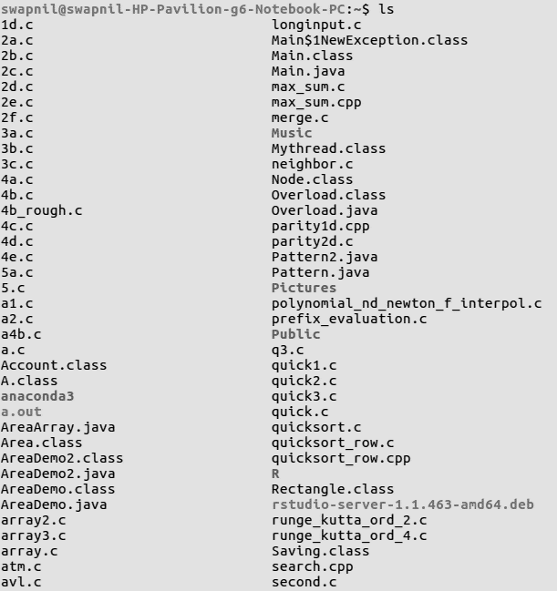

**Assignment-2**

**Problem Statement:** List all the files including hidden files in your parent directory.

**Command:** ls -a

**Screen-Shot:**

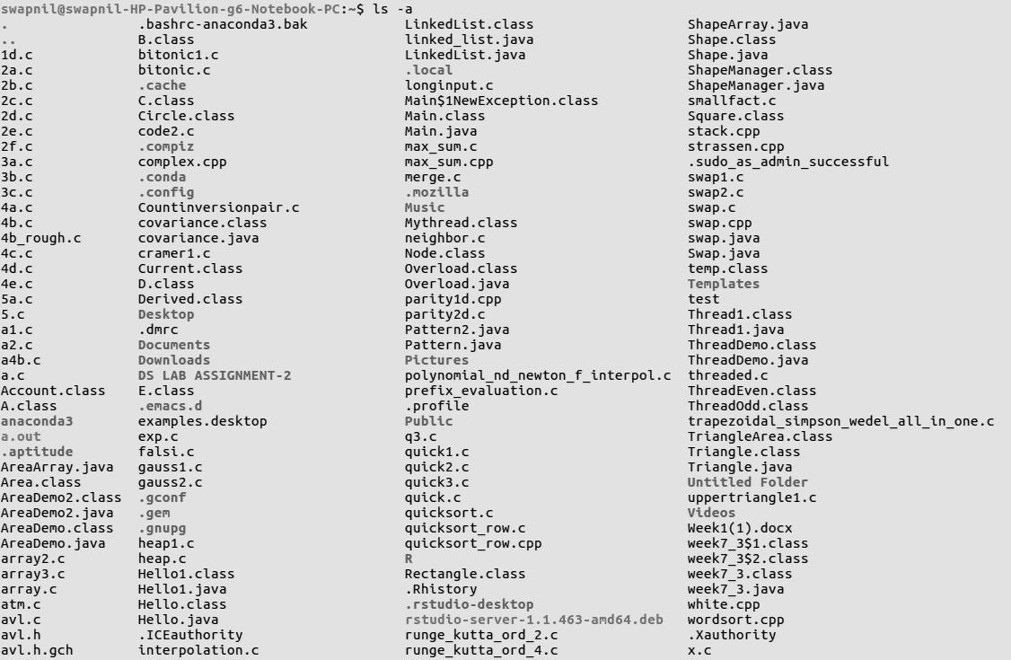

**Assignment-3**

**Problem Statement:** List only the directory files in your current directory.

**Command:** ls -d \*/

**Screen-Shot:**



**Assignment-4**

**Problem Statement:** Create a file ‘text 1’ by taking input from the keyboard.

**Command:**

touch text1.txt

nano text1.txt

**Screen-Shot:**

C:\Users\USER\Desktop\OS\os sc\os_q4_1.png

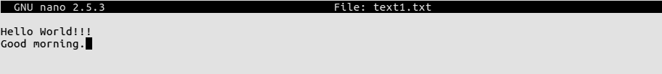

**Assignment-5**

**Problem Statement:** Copy the contents of file’ text1’ to another file ‘text2’.

**Command:**

cp text1.txt text2.txt

nano text2.txt

**Screen-Shot:**

C:\Users\USER\Desktop\OS\os sc\os_q5_1.png

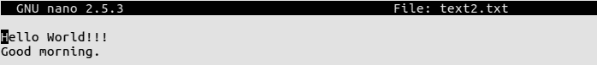

**Assignment-6**

**Problem Statement:** Append the contents of file ‘text2 ‘to file ‘text1’.

**Command:**

cat text2.txt >> text1.txt

nano text1.txt

**Screen-Shot:**

C:\Users\USER\Desktop\OS\os sc\os_q4_1.png



C:\Users\USER\Desktop\OS\os sc\os_q6_3.png

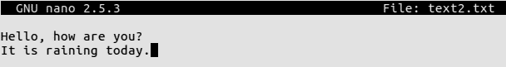

C:\Users\USER\Desktop\OS\os sc\os_q6_7.png

C:\Users\USER\Desktop\OS\os sc\os_q6_1.png

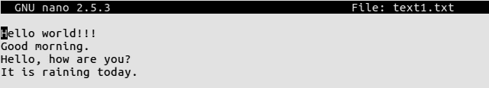

**Assignment-7**

**Problem Statement:** Count the number of lines in the file ‘text1’.

**Command:** wc -l text1.txt

**Screen-Shot:**

C:\Users\USER\Desktop\OS\os sc\os_q7.png